The Flywheel
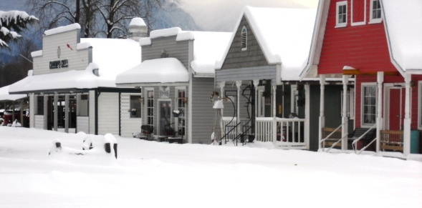
Newsletter of the Atchelitz Threshermen's Association Vol. 35, No. 2 February 2017

"A non-profit organization dedicated to the preservation of our historic past"

Atchelitz Threshermen's Association Please send comments or articles to: atachwk@gmail.com
44146 Luckakuck Way www.atchelitz.ca/www.atchelitz.com
Chilliwack B.C. V2R 4A7 604-858-2119 Check us out on Facebook!

Coming events
General meeting February 14, 2017 in the Canora 7:30 p.m.
Christmas Potluck February 25, 2017 at Atchelitz Hall 6542 Lickman Rd.
Board meeting February 28, 2017 in the Canora at 7:00 p.m.

Barb Walker, 1930-2017

We lost one of our favourite people on January 10th. After a short illness, Barb Walker died at the tender age of 87. A wonderful memorial was held at the ATA, with about 100 people attending. Barb spent her time at ATA at the desk in the Pioneer Museum, and for a lot of people she really was the heart of the organization. She will be sorely missed.

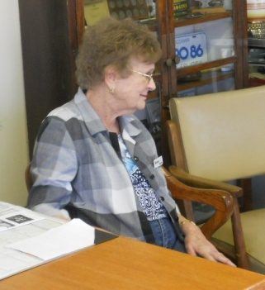
Barb walking with and Dave Reid in happier days

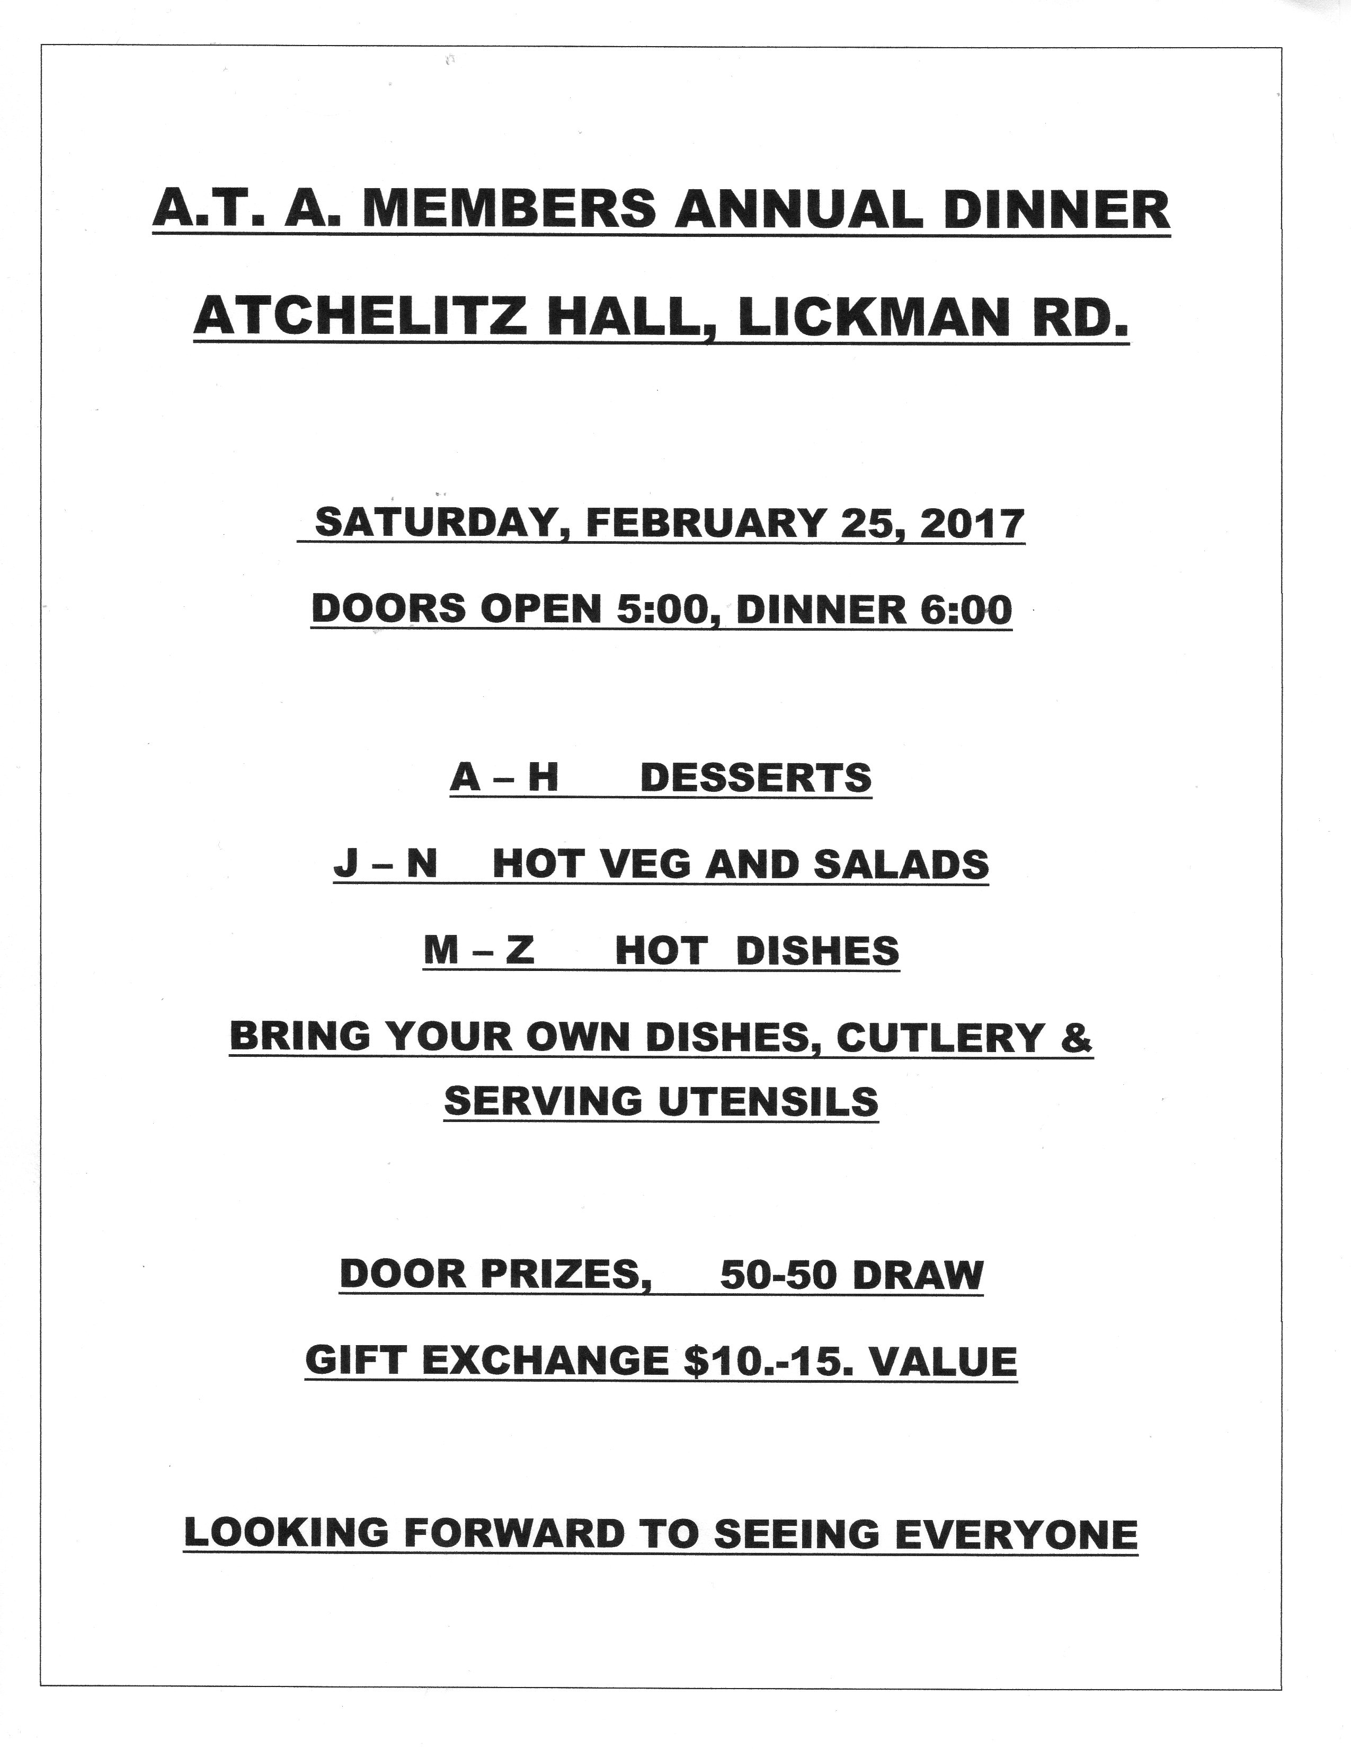

ATA’s E-Mail Address
Please note that we have a new e-mail address: atachwk@gmail.com

Ground Hog Update By Dave Dirks

It’s been a little cold in my shop, but in between warm up coffees, I was able to complete the last two things. I rebuilt the motor mounts. The motor mount is on a swivel. It was very loose and sloppy. I rebuilt the hinge, using two pillow block bearings. This worked very well. I also improved the linkage on the clutch engagement lever.
The last thing I built was a ‘V’ belt safety shield. When I saw some of the other “Ground Hogs” online, I noticed they all had shields over the belts. So I built one for ours.
So now, after it warms up a little more, I’ll finish the painting. It’s been fun. D.D.

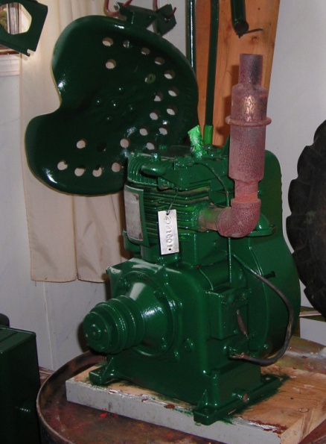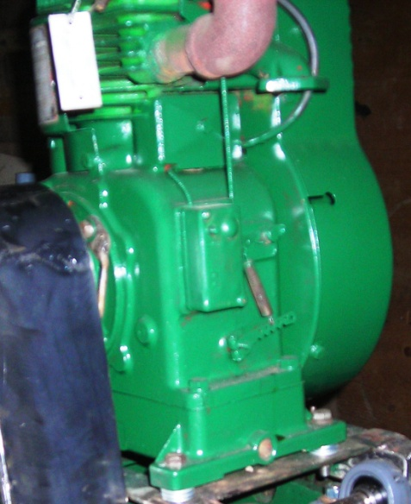

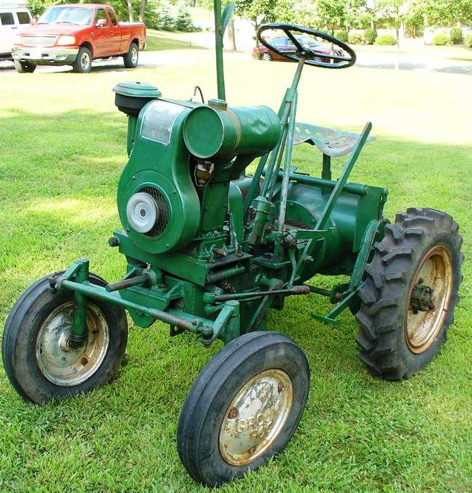
When it’s restored the GroundHog will look better than this one!

2017 Yard Sale

Although the yard sale doesn’t occur until the May long weekend, it’s time to start thinking about what you would like to donate for the sale. For those who live in complexes, you might think about asking your neighbours to donate their leftovers from their own garage sales. We are unable to accept donations of TV’s and large furniture.

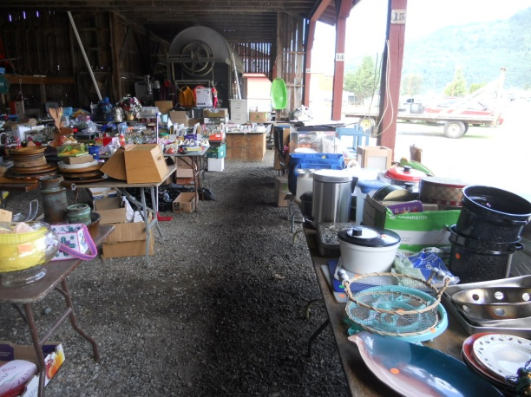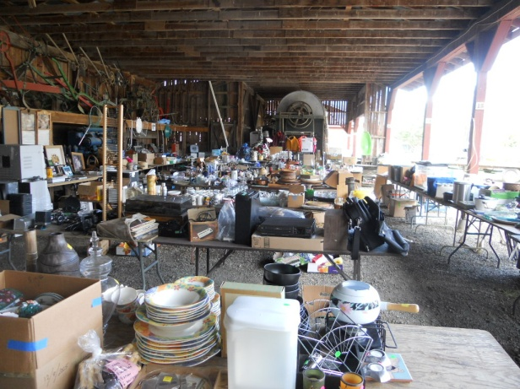
Last year’s yard sale

Wanted

A volunteer maintenance person is required for the Canora and Pioneer Buildings. Duties include: cleaning washrooms and floors, maintaining firewood, ordering paper supplies, dusting.
Talk to Ron Finnigan or John Black for details.

Yet more about the Canora
We were given a copy of Norman Hacking’s Prince Ships of Northern BC by Bill Priestly. On page 50 there’s some more info about the S.S. Canora. It was originally ordered to provide a passenger link between the Victoria to Patricia Bay line, the Canadian Northern Railway ordered the Canora from the Davie Shipbuilding and Repair Co. of Lauzon, Quebec. The Canora was 2,383 gross tons and was 308 feet ling. The Canora was designed as a passenger ship, but the passenger aspect was never completed. Just before the Canora left for BC, it was rammed by another ship. The Canora left Quebec City on September 29, 1918 and arrived in Victoria on December 7th. Because the war was on, the ship was armed with a four-inch gun. The ship went into service, but when the Canadian Northern was taken over by Canadian National, it was turned into a rail ferry.

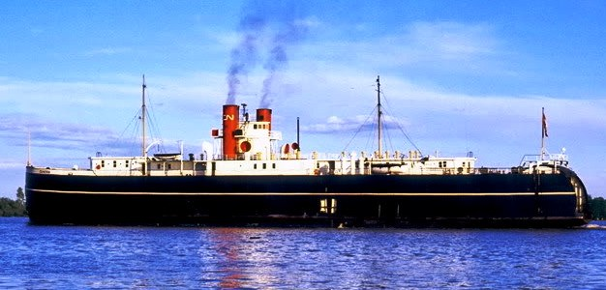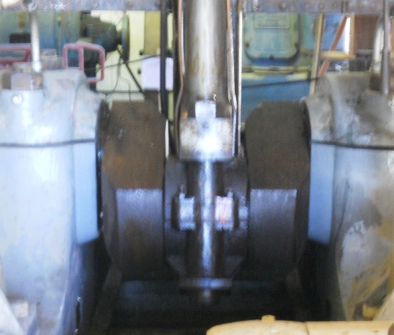

For Sale

Needed, an F124 continental motor to fit a Massey-Harris tractor; contact Norm
Wilson shop foreman at Fortins 604-795-9739 or normw@fortins.com

John Deere Tractors for sale. JD 830 Diesel, JD 730 Diesel, JD 730 Diesel with loader, JD 720 Diesel Project tractor, not seized, JD 720 Diesel Cab Parts tractor, not seized, JD 730 Diesel Parts tractor, broken block, good tin. Ask for Shawn 778-888-3700.

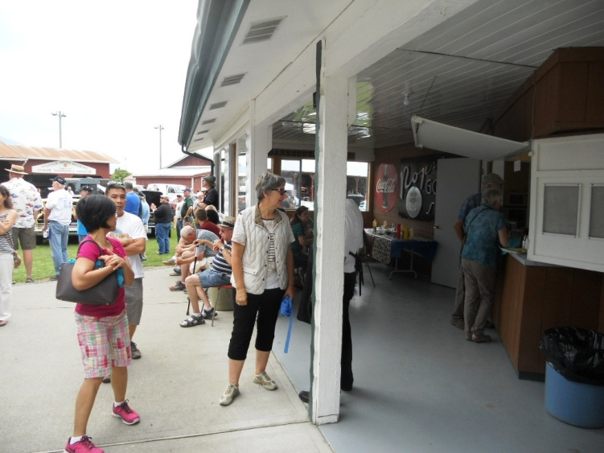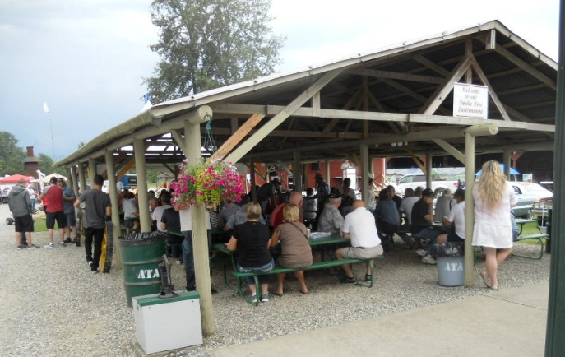

ATA Executive Board

President Ray Ramey 798-8711 ramey@telus.net
Vice-President Stuart Vanderkooi 819-5002 ssretired@telus.net
Treasurer Donna Wurst 864-1909 donig@shaw.ca
Secretary John Black 846-6850 johnwblack@shaw.ca
Directors Richard Laffere 793-4451 rblaffere@hotmail.com
Deborah Dempster 792-8599 debdempster@shaw.ca
Fred Giesler 858-7187
Dwayne Huseby 845-0096 dlh62@telus.net
Will Dempster 792-8599 wjdempster@shaw.ca
Gordon Jackson 858-4080 elainejackson@gmail.com
Committees:
Storage & Rentals Ray Ramey 796-8764 ramey@telus.net
Inventory & Membership Jerry Parkhill 794-3652 c-park@telus.net
Booking Dwayne Huseby 845-0096 dlh62@telus.net
Mechanical Ron Finnigan 819-2373 finni2@shaw.ca
Library John Black 846-6850 johnwblack@shaw.ca
PR Richard Laffere (Chair) 793-4451 rblaffere@hotmail.com
Museum John Black (Chair) 846-6850 johnwblack@shaw.ca
Kitchen Donna Wurst, Bill Priestly, Barb Laffere, Bob Lemieux, Shirley Vanderkooi,

JESPERSON'S
AUTO REPAIR LTD.
Complete Auto and Fleet Repair
Custom Exhaust . Brakes . RV's . Trailers
Gerard Arink Rick Funk
Phone: 604.792.0674 45700 Railway Ave.
Fax: 604.792.9066 Chilliwack, BC
V2P 1L3
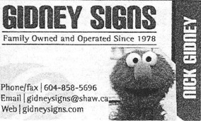
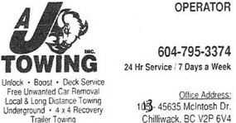 | 